GLOBAL OPTIONS AND LINKAGES

“FACILITATING INNOVATION AND TRANSFORMATIVE CHANGE
IN RURAL DEVELOPMENT WITHIN COMPLEX ADAPTIVE SYSTEMS ”

INTRODUCTION
Innovation in the context of rural development is often understood as progress within technological aspects (external behaviour). This article argues that innovation takes place when new behaviour results from a change in values and beliefs – that is, when change is not simply a external behaviour but a reflection of an internal change in people’s way of thinking, mind-sets. This article consists of 2 parts: Part A is about innovation in rural development within a complex adaptive system (CAS) while Part B focuses on change facilitation and the role of the facilitator therein. It argues in favour of a paradigm shift in:
- Viewing a rural development process as a set of co-evolving complex adaptive systems through which new ideas, innovations and human development emerge;
- Including therein the psychosocial “drivers” of rural development in addition to the current “external” ones; including the understanding of how people’s frames of mind evolve from an informal (pre-modern) to a modern (conventional) to post-modern (alternative) and to a systemic (integral) way of thinking;
- Change facilitation as a process designed to foster the co-evolution of complex adaptive systems – supporting farmers and all stakeholders in the system in effective learning and ownership (Annex 1);
- Change facilitation as a way to nurture the capacity of farmers and of all stakeholders in the system to think and feel in terms of:
  - Perceptions: the ability to see a situation from different perspectives – from 1st, 2nd, 3rd …positions;
  - Time: short, medium and long term; to change from understanding a situation “in-time” to understanding it “through-time”;
  - Space: evolution of consciousness / awareness from egocentric to ethnocentric and to world-centric worldviews.
This article also refers to a possible paradigm shift by international development actors to include these major changes in their development cooperation processes – and to consider how these processes are affected by the world’s complex systemic crises (economic, financial, education, hunger, poverty, inequalities, ethnic / religious fundamentalism, ecological, corruption, etc.)

PART A: A RURAL INNOVATION PROCESS WITHIN A COMPLEX ADAPTIVE SYSTEM

- Creativity refers to an individual or collective state of mind that permits a new idea to emerge leading to an invention, i.e. the first idea about a new product, method, process. An innovation arises once an invention is developed and applied on a commercial scale.

- Farmers / rural entrepreneurs (like all human beings) can be seen in themselves as open complex adaptive systems as they interact and adjust continuously to the environment in which they live – for example, changing weather conditions, emerging new markets, political changes, etc. In so doing, they each go through a learning process leading them to change their daily actions / behaviour; knowledge, capabilities and skills; values and beliefs, their way of thinking, motivation and working traits; and even their role or function in the community.

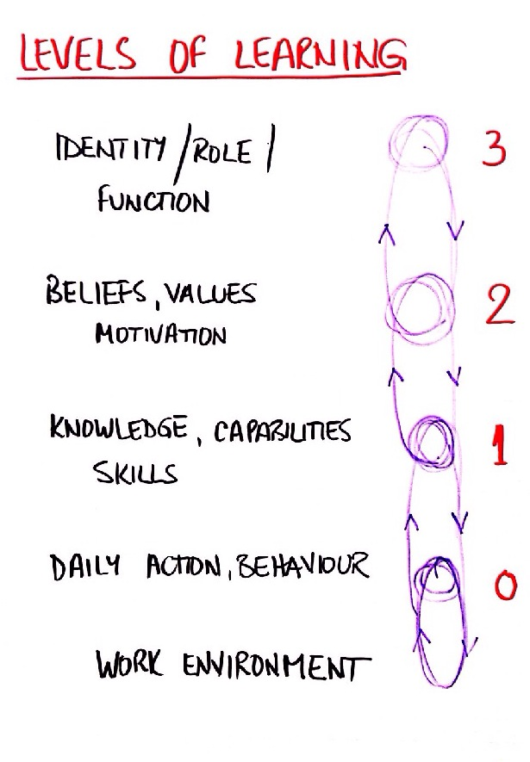
Fig.1: Levels of learning

Interactions by a farmer and others with their work environment may not lead to any change in their daily work practice – no learning (0). However, most people want to improve results of their day’s work – especially when their motivation traits, their deeper values and beliefs, and sense of self are triggered by circumstances.

When this occurs:
1. They may be motivated to learn how to change their skills, capabilities and knowledge (K,C,S);
2. Which in turn may lead them eventually to take on new beliefs and values (B,V) about what they do and to change their view of their community or the world in which they live.
3. In some cases the learning process may lead further to a change in their sense of self/identity (I) and their role in their community.

While level 1 is about “incremental” learning and change, levels 2 and 3 are about “transformative” learning and change that can be sustained through time.

- A smallholder farmer community may not be aware that his/her current daily work practice is no longer able to cope with changes in its work environment and its life conditions – or he/she may not be capable of doing anything about it. S/he might be in a state of 0 learning from his daily actions / behaviour or even in a state of denial – a so-called “stuck state”. In this case there is deep resignation within the community because the situation has been bad for too long. They have lost all hope for a possible change and often cannot imagine that change is at all possible. In some cases there is a strong expectation for help from outside (dependency trap). Possible causes are issues related to the current situation of the economy, culture, politics, environment, internal conflicts, education, etc.

- What motivates people to help themselves, to take initiative, to be creative and inventive in order to get out of a “stuck state”? From an Integral/CAS/humanistic/potential-oriented perspective, human beings have all the internal resources they need to cope with their living conditions; yet they do not always use these resources. A need to change their way of thinking, values, and beliefs emerges gradually as people become aware / conscious that their living conditions have changed in a very significant way (see Annex 2: About Spiral Dynamics). They are then no longer aligned with their environment. Through this gap, development and innovation are triggered and people’s ways of thinking evolve in line with changes in their environment in terms of:
- How to fulfil survival needs;
- Informal family, clan, tribal ties;
- Self-development, power, egocentricity;
- Strict hierarchical structures, rules and procedures;
- Achievement, goal-setting, effectiveness; wealth creation;
- Inclusiveness (respecting all minorities), environmental protection, ecology;
- Systemic, integral, synthesis, balance of the whole, able to hold different perspectives and to align them within CAS, focus on flow rather than resistance to old structures.

- These misalignments can be seen between farmers and their community (or between community and districts/country); they appear between:
- Farmers’ internal mindsets, values, beliefs, thinking styles and the way they are expressed in their daily actions and behaviour;
  - Farmers’ internal mindsets, values, beliefs, thinking styles and those predominant in the community’s culture, traditions, social norms as reflected structures, institutions, policies;
  - Farmers’ daily actions and behaviour and his / her community / society structures, systems etc;
  - The community’s culture, traditions, social norms and the way they are reflected in community structures, institutions, policies; daily work practice.
These 4 perspectives (see Annex 3) and make it possible to have a comprehensive view of development issues related to a farmer’s innovation and a farmer community.

- A farmer feels “consciously incompetent” (level of learning 1) and has an idea that may enable him or her and the community to adapt to changes in its work environment / living conditions; this idea may have been triggered in a variety of ways:
- Internal dream or vision emerging through life supported by the strength of his own belief and values in the idea; internal dialogue
- Recent event / news / opportunity arising in the community, district and / or country.
- Discussions with family, relatives, friends (inner circle) and others in the community who might have relevant knowledge, experience, skills.
These interactions are at the start of a process from which the boundaries of an “innovation system” might emerge to include support / partnerships of other stakeholders – at the community, district and / or national levels.

- The farmer identifies all stakeholders who are critical for the innovation process – that is, those with whom he needs to establish trustworthy working relationships in order to convert his idea into an innovation with commercial and social impact on the co-evolution of the community. These stakeholders may be found within the community but also at the
district and national levels.

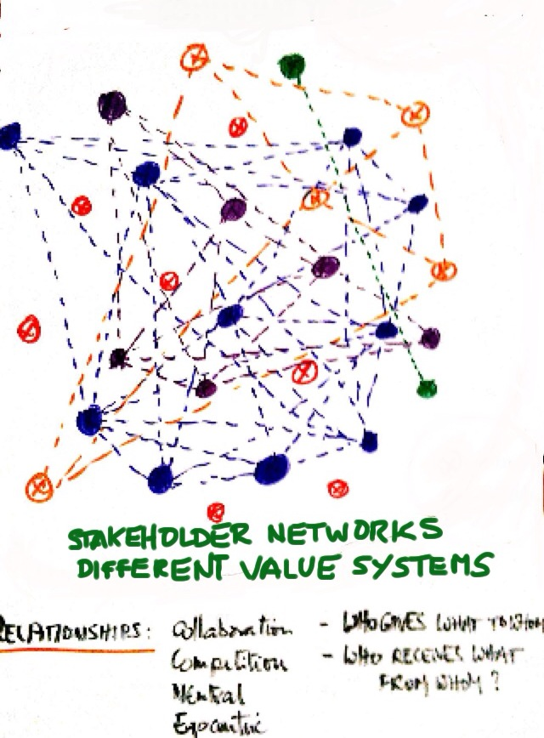

Fig 2: Stakeholder networks and value systems in the community

- The farmer discusses with all stakeholders (community, district and national levels) to be involved in his innovation proposal in order to agree on a set of activities that would need to be done and to identify the possible contribution of each stakeholder, such as input suppliers, extension agents, traders, local government, etc.

- On this basis, the farmer and relevant stakeholders at a joint meeting will develop a common understanding of how they will work together on the farmer’s innovative proposal. The process of turning the proposal into reality may be agreed upon at this time in the form of “partnering agreements”. The need to involve international stakeholders in the farmer’s innovation proposal, that is bi- or multilateral development cooperation agencies, NGOs, donors etc may be assessed at this point. The farmer will now have determined the flexible boundaries of his innovation system:

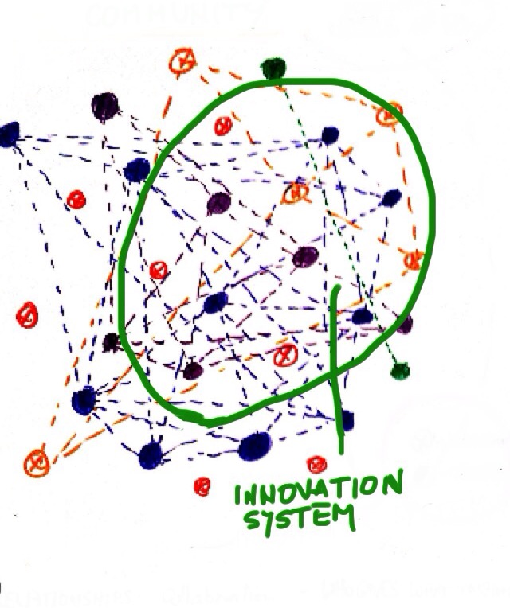
Fig. 3: The farmer’s innovation system may include stakeholders at community, district, national and international levels

- The stakeholders in the farmer’s innovation system will interact and learn from each other how the innovation will be best implemented – as they interact also with the continuous changes in their environment outside the farmer’s innovation system at community, district and / or national levels. Facilitation through the process of learning might be critical at this stage. The innovation process will be the subject of continuous change and adjustments – and in doing so new ideas and ways of thinking about the innovation will progressively emerge as a result of all stakeholder interactions. New stakeholders may enter the innovation system while others may leave. A stage of “conscious competence” will have been reached supported by effective monitoring (see Annex 4).

- Thus, a point may be reached when a critical number of stakeholders “discover” that they have very similar values and beliefs about the innovation proposal as it evolves and that they have similar ways of thinking about it – for example the need for rules and procedures, orderly accounting, for goal-setting, efficiency, for being inclusive about members of the community, protecting the environment etc. This critical number of stakeholders constitute “leverage” points in the system and capable to lead all other stakeholders towards the success of the innovation in the community and beyond. This is the start of level 2 and 3 learning – where stakeholders become “unconsciously competent” and confident about their ability to transform their situation in line with their changing environment.

- The continuous changes of the complex system require a process of monitoring from different perspectives in order to ensure adaptation to changing circumstances. Monitoring is therefore critical for the co-evolution of the farmer’s innovation together with that of the community (see Annex 4). It is the complexity facilitator’s dashboard.

ABOUT THE CO-EVOLUTION OF COMPLEX ADAPTIVE SYSTEMS (CAS)

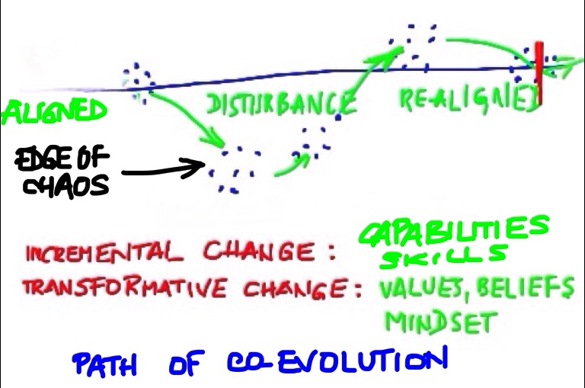
Fig. 4: Path of co-evolution
Change is the only thing that is permanent in the universe. "Everything changes and nothing remains still ... and ... you cannot step twice into the same stream"
Birds flying in formation, schools of fish are CAS, continuously adapting to their environment / living conditions.
And so do individual human beings and society as a whole. While human beings are CAS in themselves, they are also stakeholders in the systems in which they live and they make things happen! Their actions and behaviour are driven by what they believe and perceive to be most important to them. Each is unique and different from the next one. No person’s behaviour will be the same in all conditions; each one adapts over time and has an impact on others in the system.
Through interactions and networking, people learn from each other – not always in a deliberate and conscious manner. Order is emergent and self-organising – there is no central control in the system and relationships are in fact the system’s coordinating mechanisms, similar to the notion of “swarm intelligence.”
A CAS has its own identity: the whole is larger than the sum of its parts – such is also the case of a car that is greater than the sum of its parts and has a unique identity.
Like a flock of birds, simple rules can generate purposeful behaviour – in a crisis there is no time to wait for a distant body to provide instructions after “careful study”.
As they learn from interaction with their environment, people adopt new knowledge, capabilities and skills with which to improve how they carry out their daily activities (incremental change).
However, deeper learning can lead to changing the way people think, their worldviews, what they value most and consider most important in their daily activities etc – that is, to a change in the value system that drives innovation and how they behave in their daily work practice (transformative change).
Interactions between people with similar / same values and beliefs generally constitute leverage points for change in whole system; leading to scaling the innovation out and up .
This process of continuous change of stakeholders and their system is known as co-evolution in a quest for alignment with their ever changing environment / life conditions.
“Complexity facilitators” or “complexity leaders” are conscious of the characteristics of complex adaptive systems and that they can be most creative when they are at the edge of chaos – that is, when they are between states of order and disorder. This is when creativity and new ideas leading to invention and possible innovations appear most often.
New ideas appear in unexpected directions. Complexity facilitators can nudge the system in the most appropriate direction by encouraging networking and conscious learning.

PART B: FACILITATING THE CO-EVOLUTION OF A COMPLEX ADAPTIVE SYSTEM

The purpose of change facilitation is to support individuals/teams within a community to come up with their own ideas and visions for change and innovation – and not to enforce change by bringing in outside concepts. It is important to make this differentiation because in the first case, if the seed of change takes root in the community, there is a strong sense of ownership and therefore better chances for success. Facilitation processes are designed to foster / nurture the co-evolution of a farming community.
More specifically, complexity facilitators support farmers in a process that involves:
- Spotting / identifying ideas that have innovation potential;
- Assessing the potential innovation against the background of their livelihood system;
- Identifying and visualizing community stakeholders who are critical for the respective innovation process – conducting Meshworks;
- Identifying knowledge “centres” that are critical for the innovation process – conducting Meshworks;
- Identifying and nurturing formal and informal networks stakeholder interaction, developing means to support network interaction favouring the innovation process;
- Identifying misalignments between stakeholders and the environment and use appropriate tools to bridge the gap between them and support realignment;
- Assessing the co-evolution of system stakeholders by collecting relevant data and using a set of evidence indicators from 3 perceptual positions – Meshworks.
- Identifying potential leverage points in the system that may lead to a tipping point for change in the community as a whole;
- Identifying possibilities for scaling the innovation out and up;
- Effective learning and participation so that farmers’ ownership of the innovative change reaches the level of sustainability (Annex 1);
- Nurturing farmers’ capacity to think gradually in terms of:
- Perceptions: the ability to see a situation from 1st, 2nd, 3rd …. positions;
- Time: changing from understanding a situation “in-time” to understanding it “through-time”; thinking in medium and long term horizons.
The design of facilitation processes:

Complexity facilitators design processes specific to the facilitation of each innovation proposal; these facilitation processes and storyboarding are designed to:
- Facilitate connections and interactions between those who have knowledge and those who have not;
- Create a supportive environment;
- Catalyse bottom-up networks (formal and informal);
- Embrace uncertainty; adapt to tensions and constraints;
- Encourage creativity;
- Support learning – individual and collective;
- Provide for “meaning-making” for self (re-) organisation;
- Stabilise feedback so that emergent change does not spin out of control;
- Amplify actions that encourage scaling up and scaling out;
- Are sensitive to the advantages / disadvantages of system coupling.

Above all, a facilitator is able to communicate highly effectively with people of different value systems, beliefs, motivation traits, attitude etc. In addition, he / she accepts that success is not necessarily dependent on charisma and power.
Knowledge, methods, tools:
The complexity facilitator takes a helicopter view of the innovation system – s/he has to act from a stage 7 (integral, systemic) or 8 (holistic) of the path of human evolution (Spiral Dynamics, Annex 2) and has access to 4 perspectives of the development issues in the farming community (Integral Theory, Annex 3). As such, they are able to be neutral observers of the system’s dynamics, avoid all value judgements and taking sides between positions of different stakeholders.

Of major importance is their capacity to design processes for facilitating the co-evolution of complex systems by drawing on several methods and tools that focus on the internal / mindset side of people and social groups – such as for example:
- Systemic Alignment Model – SAM (SevenPlus Network Europe / GOAL) – Annex 4.
- Logical levels of learning (Gregory Bateson, Robert Dilts)
- Spiral Dynamics Integral (Clare Graves, Don Beck, Chris Cowan) – Annex 2.
- Integral Theory – AQAL model (Ken Wilber, Barrett Brown and others) – Annex 3.
- Theory U (Otto Scharmer, Adrian Wagner, Anne Caspari, others) – Annex 6.
- Neuro-linguistic change models and techniques for individuals and groups (NLP)
- Bohmian Dialogue (David Bohm)
- World Café (Juanita Brown, David Isaacs)
- Systemic Constellations (Bert Hellinger, M. von Kibéd, Marilyn Droog, others)
- Appreciative Inquiry (AI) (D. Cooperrider, D. Whitney, others)
- Autopoiesis (Humberto Maturana, Francisco Varela)
- Actor theories (Michel Callon, Bruno Latour and others)
- Archetypes (C.Jung, P. Senge and others)
- Culture theories (G. Hofstede, F. Trompenaars, others)
- Modernisation theories (W. Rostow, D. McClelland, others)

THE NEXT STEPS:
While considerable experience has been acquired from the use of SAM for nearly 10 years – however, most has been obtained by facilitating organisational development of public and private sector institutions. Insofar as development is concerned experience has focused mainly on the facilitation of stakeholder / situation analysis phase of SAM. Examples related to rural innovation are:
- The Enabling Rural Innovation (ERI) model has been reviewed to set it within the frame of a complex adaptive system and to take full account stakeholder mindsets (internal drivers) by plugging in SAM.
- CDR Innovation Fund: this innovation process was designed on the basis of SAM.

It is expected that these will be tested in the field on innovation proposals such as those selected by CDR’s Innovation Fund and on selected UNIDO projects.

At an Expert Group Meeting organised by UNIDO, CDR/BOKU and GOAL, discussions focused on Theory U (see Annex 6) and how it can be used as a frame for the process in conjunction with some methods and tools listed above such as SAM, Theory U, Spiral Dynamics, Integral Theory, NLP based change models and techniques, Appreciative Inquiry, Voice Dialogue.

A GOAL research team is now exploring which methods / tools can be used in the most effective way to design facilitation processes within the Theory U process and the co-evolution of complex adaptive systems (see Annex 6).

FURTHER READING

- “AIZ Leadership Tool Box: Leadership for Global Responsibility”, Deutsche Akademie für Internationale Zusammenarbeit, 2013. (http://www3.giz.de/vez/)
- D. Beck and C. C. Cowan: “Spiral dynamics: mastering values, leadership, and change: exploring the new science of memetics”. Cambridge Mass, Blackwell Business, 1996
- D. Bohm: “On Dialogue”, Routledge Classics, 1996.
- B. Brown: “Complexity Leadership: An Overview and Key Limitations” in the Integral Leadership Review (ILR), October 2011. http://integralleadershipreview.com
- B. Brown: “Four Worlds of Sustainability”, Integral Sustainability Center, 2007.
- A. de Faria: “Towards an Evolutionary Complex Systems Approach to International Development”, ILR, January 2013. http://integralleadershipreview.com
- A. de Faria: “Spiral Dynamics Integral in Action in a Roma Community in Romania”, Integral Leadership Review, October 2011. http://integralleadershipreview.com
- A. de Faria: “The People Dimension in Development and Development Cooperation,” The Quality Assurance Company, 2004.
- A. Fowler: “Complexity thinking and social development connecting worlds of Knowledge” in The Broker Online, Issue no. 7, April 2008; www.thebrokeronline.eu
- A. Gauthier: “Emerging Concepts and Forms of Integral Leadership Embodying a Radically New Development Paradigm”, in Integral Leadership Review, October 2011.
- A. Hall and N. Clark: “What Do Complex Adaptive Systems Look Like And What Are The Implications For Innovation Policy?” Journal of International Development, vol. 22, 2010.
- F. Hartwich and U. Scheidegger: “Fostering Innovation Networks: the Missing Piece in Rural Development?” Rural Development News 1/2010.
- G. Hochaska: “An Integral Approach to International Development” Integral International Development Center, Integral University, Drishti-Centre for Integral Action.
- J. Markard, R. Raven, B. Truffer: “Sustainability Transitions: an emerging field of research and its prospects,” Research Policy 41, Elsevier 2012 www.elsevier.com/locate/respol
- D. Meadows: “Leverage Points: How to Intervene in a System,” the Sustainability Institute, 1999.
- S. McDonald: “Human Evolution: Who are we Becoming?” in http://www.eman8.net/blog/?p=489, December 2011.
- E. Morin: “Introduction à la pensée complexe”, Editions du Seuil, Paris 2005.
- E. Morin: “La Voie”, Librairie Arthème Fayard / Pluriel, Paris 2012.
- S. Nederhof, M. Wongtschowski, and F. van der Lee (eds.): “Putting Heads Together: Agricultural Innovation Platforms in Practice,” Bulletin 396 Development Policy and Practice, KIT Publishers, 2011.
- H. Nauheimer: “The Change Management Toolbook: a collection of tools methods and strategies”.
- J. O’Connor and I. McDermott: “The Art of Systems Thinking”, London, 1997.
- J. Pretty: “Regenerating Agriculture. Policies and practices for sustainability and self-reliance“, Earthscan Publications, London, 1995
- N. Rölling: “Conceptual and Innovative Developments in Innovation”, 2009.
- I. Scoones and J. Thompson: “Farmer First Revisited. Innovation for Agricultural Research and Development”, Practical Action Publishing Ltd., Warwickshire, 2009
- UNIDO: “Agro-Value Chain Analysis and Development”, Vienna, 2009.
- UNIDO, IFAD, DIIS: “Pro-poor Value Chain: 25 Guiding Questions for Designing and Implementing Agro-industry projects”, UNIDO 2011.
- O. Scharmer and K. Kaufer: “Leading From the Emerging Future: From Ego-system to Eco-system Economies”, Berret-Koehler Publishers, July 2013.
- S. Schuman: “The IAF Handbook of Group Facilitation - Best Practices from the Leading Organization in Facilitation”, Wiley and Sons, 2005.
- The Open University: “Invention and innovation: an introduction.” OpenLearn, http://open-learn.open.ac.uk/
- K. Wilber: “A Theory of Everything: An integral vision for business, politics, science, and spirituality.” London, Shambala, 2000.

Some case studies – Integral development

- K. O’Brien: Climate Change Adaptation, Poverty Reduction and Sustainability: Is an Integral Approach the Answer? University of Oslo, 2008
- L. Chacon and J. Gonzalez: Towards an Integral theory of Human Needs, 2008
- P. Cohen: Sustainable Communities in South Africa, 2007
- G. Linscott: “Values and Sustainable Development: case of KwaZulu Natal, South Africa”, Global Values Network, 2002.
- C. de Stoop: Integral Waste Management in Addis Ababa, Ethiopia 1998-2006.
- P. Van Schaik: Effective Schools Project, Egypt, 2005
- A. Tonkin: Case study “Middleburg Steel and Alloys”, South Africa, Global Values Network, 2002
ANNEX 1: LEVELS OF PARTICIPATION AND OWNERSHIP

Level of ownership | Type of participation | Description
Level 8 | Integral participation | People understand the dynamics of participation and use the entire Integral theory - AQAL framework - to design interventions and involve people, keeping in mind the power and differences in various systems.
Level 7 | Self-mobilisation / ownership | People participate independent of external institutions; they develop contacts with external institutions for resources and technical advice, but retain control over the use of resources.
Level 6 | Interactive participation / leadership | Participation in joint analysis leading to action plans and the formation or strengthening of institutions. They take control over local decisions – and so have a stake in maintaining structures and practices
SUSTAINABILITY THRESHOLD
Level 5 | Functional participation / managed | People participate in committees around predetermined objectives (community or supplies management); committees are formed after major decisions have been taken and are dependent on external experts – may become more self-dependent over time.
Level 4 | Participation for specific outcomes / conditional | People participate because they have to before they can receive support from government or others
Level 3 | Participation for material incentives | People participate by providing resources (labour / materials) in exchange for food, cash..
Level 2 | Participation in providing information / consulted | Answering questions from researchers and others; the results are not shared with the community; interviewers have no obligation to take their views into account.
Level 1 | Passive information / informed | People are simply told what is going to happen by those in charge of a project.

The above table helps to understand the meaning of participation and ownership and to distinguish between different types and levels. It can be useful for complexity facilitators and development practitioners in general.
ANNEX 2: SPIRAL DYNAMICS INTEGRAL
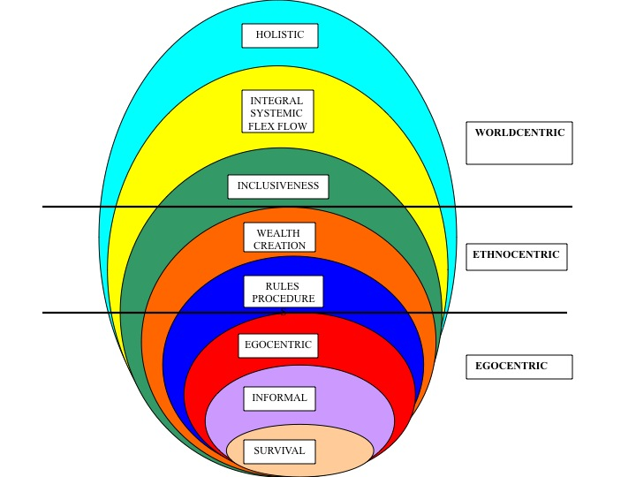
Spiral Dynamics proposes a map representing the evolution of group and individual - personal human development (as distinct from industrial, environmental and other.) Evolution is a permanent process that takes place within societies and within people as they respond to the challenges posed by different life conditions. This framework contains 7 or more stages of human development; these stages can be envisaged as holons; each new stage transcends and includes all the previous stages – each contains the values, knowledge and experience of the previous stages. (See diagram on the right).
People and groups advance in waves to the next stage in a continuum - there is no clear demarcation between the stages as they learn to cope with their life conditions. As they do, they may take on:
- Additional knowledge, capabilities and skills (K,C,S) – an incremental change;
- New values and beliefs (B,V) and a new Identity (I) / role in the community – a transformative change to the next stage of human development. (See the diagram below)

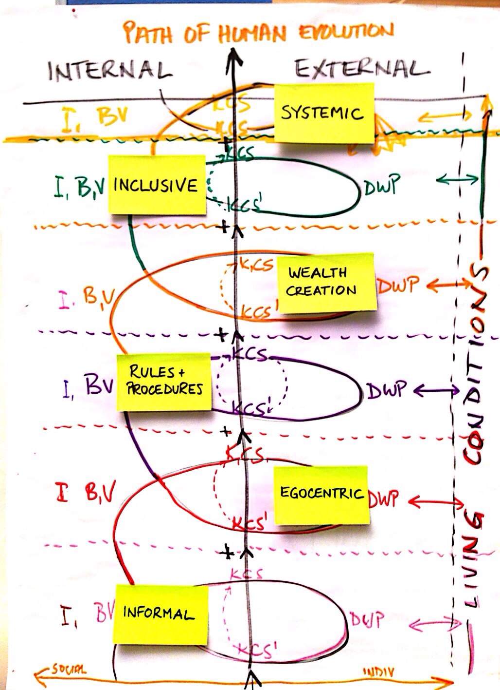
Each stage is characterised by the value systems people / society adopt in coping with the life conditions prevailing in the environment in which they live.
People’s value systems may differ according to the situation they happen to be in (at home, work, politics, war, play etc) and may revert to value systems characteristic of earlier stages of human development. The most effective value system is that which allows people to cope best with the life conditions in their environment – it is not necessarily the “latest / highest” stage!
People are not able to bypass a stage and move directly to a later one. Nevertheless, it can be very beneficial for them to imagine their situation in a later stage.
A UNIDO project for the advancement of women entrepreneurs in the garment and textile industry (1998): used NLP techniques; the women entrepreneurs participating in the design of the project were led to dream what their ideal situation would be 5 years ahead. They then designed a realistic project to achieve that hope. Today, their expectations have been largely met.
ANNEX 3: INTEGRAL THEORY – 4 QUADRANTS, 4 PERSPECTIVES
The four quadrants of the Integral Theory provide a comprehensive view considering all possible perspectives of a given situation. It places the individual into relation to the community and the society he/she lives in:
INTERNAL EXTERNAL
The Individual’s:  Inner experience  Feelings  Value systems  Beliefs  Identity | The Individual’s:  Capabilities  Skills  Actions  Results  Plans
The Community’s:  World View  Customs and values  Social norms  Relationships  Mutual understanding | The community system’s:  Economy  Ecology  Resources  Social and political institutions  Policies

The term “Internal” means the inner or subjective view on an individual / community. The term “External” means the outer or objective fact based view on an individual and the society he/she lives in. Considering all these four perspectives in a development process is crucial in order to identify:
- The main strengths in each of the quadrants which are beneficial and have to be emphasized on
- The main weaknesses / challenges / risks which have to be faced and worked on.
For all four perspectives, there are different methodologies to be used to have a comprehensive understanding of the development issues:

Experience (Individual, internal)  Subjective, qualitative methodologies:  Includes: self-reflection, introspection, contemplation, emotional capacity building, self-inquiry, counselling, body scanning, journaling, goal-setting, meditation, prayer, rituals, vision quests, wild-nature experiences. | Behaviour (Individual, external)  Objective, quantitative methodologies:  Includes: quantitative research, scientific studies, diagnostic testing, assessments, skill building, and technical capacity development.
Culture (Community, internal)  Inter-subjective, qualitative methodologies:  Includes: dialogue, participatory methodologies, focus groups, collective visioning, trust-building exercises, group facilitation, participant-observer techniques, storytelling, appreciative inquiry, collective introspection, and other approaches of reaching a common vision and shared goals. | Systems (Community, external)  Inter-objective methodologies:  Includes: monitoring and evaluation, gap analyses, feasibility studies, technical training, policy-making, rapid appraisals, assessments, scientific studies.

The application of the Integral Framework can assist to:
- Enable sustainable and socially equitable development
- Increase efficiency and individual freedom
- Implement structure and rules where needed
- Protect people from each other and engender respect between individuals and their sense of belonging to a group.
ANNEX 4: INNOVATION PROCESS USING THE SYSTEMIC ALIGNMENT MODEL (SAM) – the basis of GOAL’s current research with CDR.

Situation analysis, identifying partners in the innovation system:

- Identify flexible boundaries: system boundaries help to view where the focus of attention lies - and there may be several sub-systems and layers within a system!

- The living conditions of the farming systems: agro-ecosystem including all economic, social, political and ecological indicators.

- Identify the main stakeholders in each system, sub-systems and the main stakeholder system. The main stakeholders are those with:
      - The Authority to take decisions;
      - The Power to prevent decisions from being implemented;
      - Influence those with the authority and / or the power to take decisions.

- For each of the main stakeholders, identify their:
  - Role / function in the system;
  - Values and beliefs about those values that support their role / function and motivate them in their daily work practice in the system; as well as their stage of human development in line with the evolution of human consciousness (see Spiral Dynamics Integral)
  - Knowledge, capabilities and skills that enable them to discharge their functions in line with their values and beliefs;
  - Daily work practice, actions, behaviour in their environment / living conditions and in line with their role, values and beliefs.

- Identify formal / informal networks of communication between the main stakeholders.

- Mapping of main stakeholders, natural resources, food / cash crops, poultry, livestock etc as required by the desired focus of attention.

- Analyse the interactions between the main stakeholders in terms of their direction, content, acceptance / adoption by others and the impact they may have on the farming community (systems and sub-systems) as a whole.

- From this analysis:
    - Understand how farmers and others in the system learn from interactions and what specifically prevents them from learning / adopting possible learnings. Learning is driven by people’s values, beliefs, motivation, commitment etc.
    - Identify potential leverage points between stakeholders in the system and sub-systems - normally, leverage points tend to appear between stakeholders with similar values and beliefs and vision about the community’s future.

Partner arrangements and responsibilities:

- Organise Meshworkshop(s) to reach a common understanding of:
    - The present situation of the community;
    - A possible shared vision of its future;
    - The intentions / goals of the community stockholders;
    - Potential partnerships aimed at achieving those goals;
    - The community structures required to enable the achievement of those goals.

- Nurture / encourage interactions through existing networks or support the creation of new networks.

- Motivate stakeholders to learn the way they like to be motivated and in line with their values and beliefs.
- Learning may lead to a change in:
  - Daily work practice, actions and behaviour;
  - Knowledge, capabilities and skills;
  - Values and beliefs about those values; motivation; personal commitment;
  - Role or function of the stakeholders in the community.

“3-D” Monitoring the innovation process and the evolution of the community:

The monitoring process addresses the following research questions:
- How do the levels of learning develop through multi-stakeholder innovation process?
- How important is the degree of alignment of levels across stakeholders?
- How do level changes relate to autonomy and self-reliance of the farmer-owner of the innovation?

A. Data domains / actor categories to be monitored
Monitoring addresses three domains / actors categories:
- Farmer-owner of the innovation
- Stakeholders that are important to the innovation
- Complexity facilitator
Type of monitoring:
- Monitoring from first position: domain 1, 3 monitor themselves / their own performance
- Monitoring from second position: facilitator (= domain 3) monitors domain 1,2
- Monitoring from third position: CDR / BOKU monitors domains 1,2,3

B. Type of data to be monitored
The evolution of an innovation system resulting from the introduction of a new idea should be measured at 5 interrelated levels:
- Changes in living conditions or work environment of a farming community during the 5 key steps of an innovation process (done for domain 1, 3):
- Changes in DWP (done for 1)
- Changes in KCS (done for 1,2,3)
- Changes in BV (transformative change) done for domains 1,2,3):
- Changes in role / function (done for domains 1,2,3):

C. Data points for monitoring
- Baseline data collection upon signature of the innovation grant contract for domains 1,2 and 3;
- Process documentation of coaching sessions and of stakeholder meetings / network interactions
- End line data collection (domains 1,2 and 3)

D. Tools needed – data entry forms and record sheets filled out by different parties.
ANNEX 5: INTERNATIONAL DEVELOPMENT – TOWARDS SYSTEMIC AND INTEGRAL PROCESSES

We base the above proposals on our subjective perception that development approaches have not had the desired impact on human development. Since the 1980s, there has been a move from “conventional” (modern) to “alternative” (post-modern) approaches. These “alternative” approaches have participation and ownership at their core and seek to allow local people to be the initiators, leaders and owners of their own development process.
Unfortunately, their overall impact has been far less than expected – learning and ownership remain illusive and generally below the threshold level (Annexes 1). Creativity and innovation by people and societies have not been given the space to flourish and, in many cases, have been stifled.
A paradigm shift is required away from the current linear modern/post-modern approach towards a complex systems approach. It entails for example the following changes:

Modern/post-modern development | Complexity – civic driven – development
Prediction. Assumption that the future is knowable and reachable by human action. | Estimation. Informed guess about how things work and interact; what change might result from human effort.
Certainty. Enough planning and effort create specific types and amounts of social change. | Uncertainty. No effort in social change guarantees desired outcomes.
Centralized. Hierarchy-based transaction and rule framework. | Devolved. Margin-driven rules and networked connectivity.
Mainstream development capital. That which is valued economically and socially. | Complex development capital. That which is valued economically, culturally, socially and symbolically.
Reliance on exogenous capital. External investments - finance, technology, know-how. | Reliance on endogenous capital. Self-mobilization of all types of valued capital.
Utilitarian development economics. Economic behaviour based on rational self-interest and equilibrium as attractors. | Conditional development economics. Economic capital co-dependent on process and fairness of rules in play, with asymmetry as critical force.
Cause-effect relationships. Logical, non-contingent relationships that can be relied on to achieve desired change. | Transactional rules. Interaction patterns that show actual relationships and their effects in contingent interaction.
Plan. Reliance on different scales of resources and scheduled actions with predetermined goals and outcomes which justify allocations. | Forecast. Investments set against a range of possible scenarios with associated degrees of attainment probability.
Planning. Gathering information and ‘buying in’ support from those who are required to implement and deliver predetermined results. | Testing. Gauging support and establishing prevailing conditions in order to try out an investment and learn from it.
Feed forward. Primary attention to future activities as planned steps and milestones. | Feedback. Iterative reflections on which connections are in operation in relation to previous conditions that will amplify or attenuate social change.
Public policies. Top-down transmission of rule preferences based on existing power arrangements. | Local discourses. Periphery-originated transmission and amplification of marginalized power assertion over recognized interests and rule selection.
Scale. ‘Vertical’ growth in size and budget. | Scale. ‘Horizontal’ growth in number and through citizen leverage.
Time. Budget, policy and project cycles. | Time. Socio-political stages of change.
Impact. Predetermined, expected changes resulting from development efforts. | Emergence. Range of changes due to development initiatives, both anticipated and unexpected.
Institutional analysis. Assessment of roles and competencies of stakeholders. | Power analysis. Identification of types and locations of power across all stakeholders.
Civic participation. Inviting citizens to get involved in processes defined, designed and managed by others. | Civic energy. Recognizing where people are locating their efforts and preferences regardless of external assistance.
Apolitical governance. Obscuring or ignoring political issues, respecting sovereignty. | Political governance. Direct concern with citizenship and the civic-political interface in governance.

ANNEX 6: THEORY U

The essence of this approach can be summarized with a single sentence: the quality of our results in a system is a function of the awareness from which the people in that system operate. The essence of Theory U is not: I think therefore I am. It is: “I attend this way, therefore it emerges that way.”

PRESENT SITUATION DESIRED SITUATION
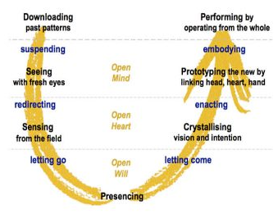

Fig. 4: Basic Theory U process

Theory U provides a path through which people and social groups can “lead” their transformation process. These steps can be facilitated through the use of several methods and tools listed in this paper.

GOAL – Global Options and Linkages, Vienna, Austria. Web: www.goalnetwork.net. GOAL collaborates with Centre for Development Research at the University of Natural Resources and Life Sciences (http://www.boku.ac.at/cdr.html) and SevenPlus Forum Europe (www.sevenplus.org).
Prepared by A. de Faria and Z. Gaspar, GOAL, for the UNIDO, CDR/BOKU, GOAL meeting: “What Makes People Innovate?” Vienna, 29-30 October 2013.
See Annex 4 for a sample process based on GOAL’s Systemic Alignment Model (SAM).
- GOAL studied the social integration of a Roma community in Romania which reflected this “stuck state” of no hope; see A. de Faria: “Spiral Dynamics Integral in Action in a Roma Community in Romania”, Integral Leadership Review, October 2011. http://integralleadershipreview.com
Read also about the basic principles of sustainable livelihoods approach: www.ifad.org/sla.
A. Hall and N. Clark: “What Do Complex Adaptive Systems Look Like And What Are The Implications For Innovation Policy?” Journal of International Development, vol. 22, 2010
For the meaning of value systems and the path of human evolution, see Annex 2.
Some researchers, such as Ken Wilber, estimate this figure to be approx 10-13% of the social group.
In systems theory, this is known as bifurcation point, that is the stage in a transition where control variables lose power, the system becomes unstable and there is likely to be much fear and uncertainty.
“Panta Rhei” – Heraclitus of Ephesus (535-475 BC)
This is an area of considerable action-research in the world as a whole. CDR/BOKU and GOAL have worked on this concept both in CDR courses and action research in Africa.
Meshworks suggest the notion of how to blend, align, integrate, stitch-together, merge, amalgamate, and coalesce. This was applied in the case of the study on Roma social integration in Romania See Spiral Dynamics Integral in Action in a Roma Community in Romania”, Integral Leadership Review, October 2011. http://integralleadershipreview.com http://www.integratedsociopsychology.net/meshworks-perspective-process.htm
“Communication and Relational Skills for Facilitators – A Manual”, Quality Assurance Company, 2004.
Study on the social integration of Roma community; organisational development at Heifer International; Coco-Mat company.
EGM “What Makes People Innovate”, Vienna, 29-30 October 2013
Based on “Integral Mentors: Participation, Ownership and Development”, Worlds of Inclusion 019. https://www.facebook.com/integralMENTORS
http://www.spiraldynamics.net/ and http://www.integratedsociopsychology.net/integrated_sociopsychology.html
UNIDO: Assistance to Textile and Garment Micro- and Small Enterprises in Uganda – video “Transforming Passion into Business, 2007.
B. Brown: “Four Worlds of Sustainability”, Integral Sustainability Center, 2007
G. Hochaska: “An Integral Approach to International Development – Exploring Quadrants”.
Formulation by Adrian Wagner, 2009.
A. de Faria: “The People Dimension in Development and Development Cooperation,” The Quality Assurance Company, 2004. http://www.youtube.com/watch?v=U49fKh5pqN4
Note - there are 2 depths of change: - Incremental change occurs when stakeholders have adopted the use of new knowledge, capabilities and skills. Such a change may not be of a sustainable nature if it is not driven by a personal commitment, motivation and values – as is found in so many project evaluation reports. - Transformative change is of a deeper nature; it occurs when stakeholders adopt new values and / or new beliefs about their values; that is, when their actions and behaviour (in daily work practice) are driven by a new and different personal commitment and motivation. Transformative change may also lead to a change in the stakeholder’s role or function in the community.
Baseline and end line data entry forms; coaching, meeting and self-monitoring record sheets.
From A. Fowler: “Complexity thinking and social development connecting worlds of Knowledge” in The Broker Online, Issue no. 7, April 2008; www.thebrokeronline.eu
See O. Scharmer and K. Kaufer: “Leading From the Emerging Future: From Ego-system to Eco-system Economies” which focuses on transforming the self, business and society.
Minds for Change – Future of Global Development Ceremony to Mark the 50th Anniversary of the BMZ Federal Ministry for Economic Cooperation and Development November 13, 2011, Berlin, by Dr. C. Otto Scharmer, MIT Sloan School of Management, Presencing Institute. www.presencing.com

